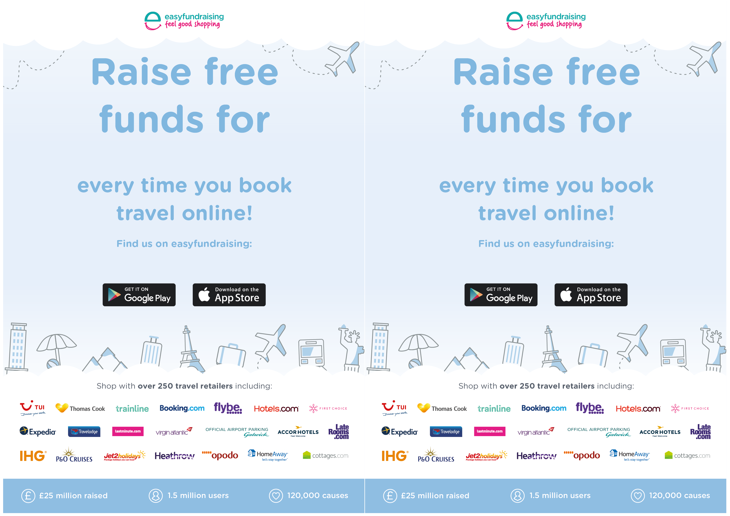­

Replace with your logo or delete

**Insert Cause Name**

Insert Cause URL

Replace with your logo or delete

Insert Cause URL

**Insert Cause Name**