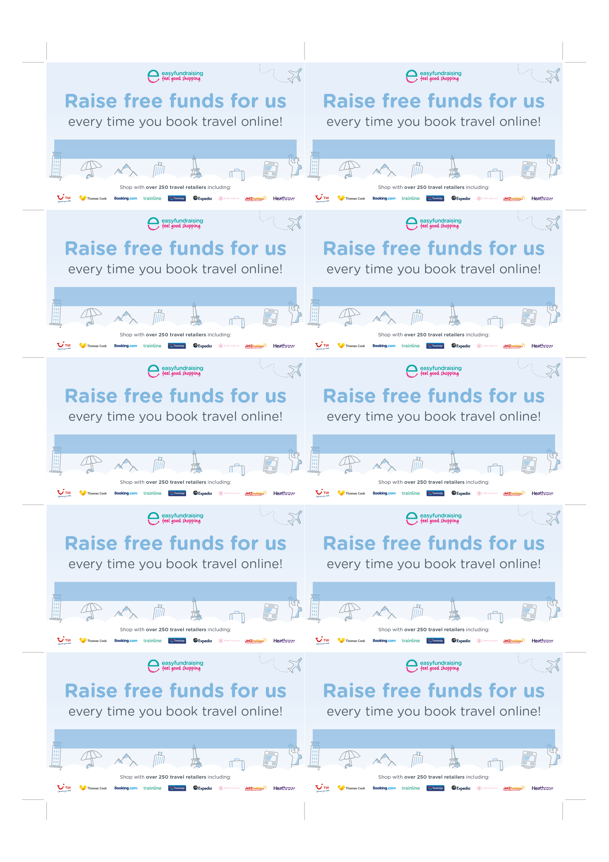

Insert Cause URL

Insert Cause URL

Insert Cause URL

Insert Cause URL

Insert Cause URL

Insert Cause URL

Insert Cause URL

Insert Cause URL

Insert Cause URL

Insert Cause URL